# BT305 Lab5

Rohit V. Sagvekar 200106056

1.Name and roll number

Rohit V. Sagvekar

200106056

2.WCSS vs k plot

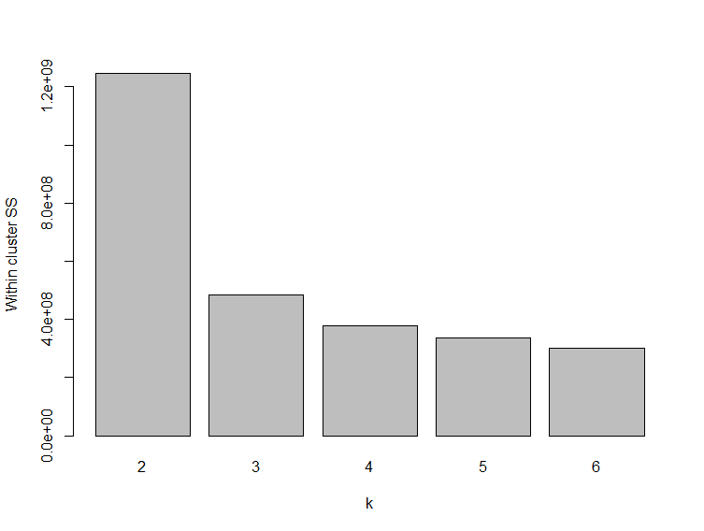

3.The number of clusters or k chosen by you for the final clustering. Give the reasoning behind your choice

Take k = 4

Because after k =4 there isn’t significant decrease in WCSS

4.Cluster diagrams: FL2.H vs FL3. H and FL3.H vs FL4.HColor the data points based on the cluster.

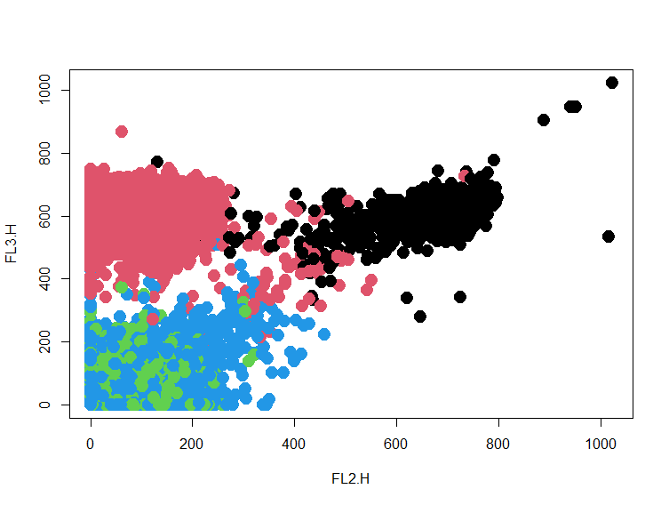FL2.H vs FL3.H

FL3.H vs FL4.H

